Level 8 -> Level 9

The goal of this level is to read the content of **data.txt** file and get the password which is the only line of text that occurs only once in the file.

Using **cat** command, we can easily display the content of **data.txt** file and using **uniq -u** we can find out the unique line. Instead of **cat, sort** command can be used which sorts the file assuming the content are ASCII. It will make easy to find the unique command. Sort is similar to cat command the only difference is that sort arrange the record in particular order.

Here, we can use command **sort data.txt | uniq -u**

**|** is used to switch from one command to the other.

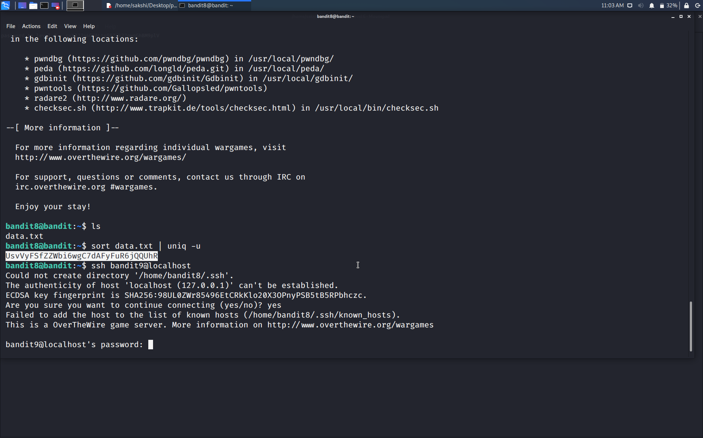

Use the command **ssh bandit9@localhost** to connect to the level 9.

Enter the password and hit enter.

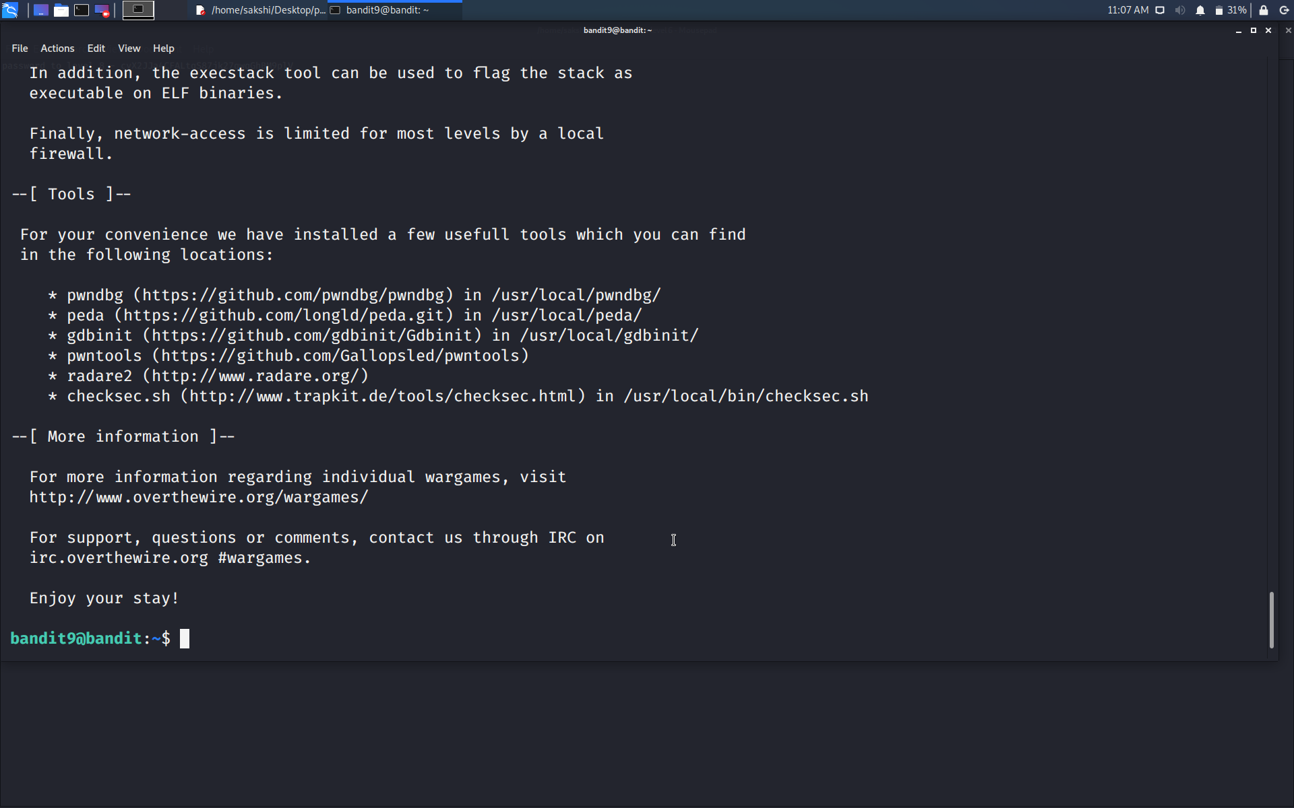

Successfully passed level 9.…